**Deploying SQL Server Virtual Machine**

**Introduction**

Fabrikam has certain applications that are associated with application and database tier both together in a single Windows Server environment. They are now looking for the same environment in Azure where they can host their application tier and database tier in a single server that will allow them to perform al the core level tasks. This includes configuring database, making RDP access to the server, deploying application, patching the server and more. Since they are migrating to Azure, they are looing for the same kind of environment in which they can deploy virtual machine in Azure which will have the SQL Server environment that is already booted up in the operating system. In the following scenario, we will be deploying a Windows Server virtual machine along with SQL Server configured in it.

**Prerequisites**

To perform this demo user must have valid Azure subscription and some knowledge on SQL Server Virtual Machine and SQL Server management studio.

**Demo**

Log-in to Azure portal with your account using [www.portal.azure.com](http://www.portal.azure.com). In Azure portal click on create a new resource and search for **SQL Server**.

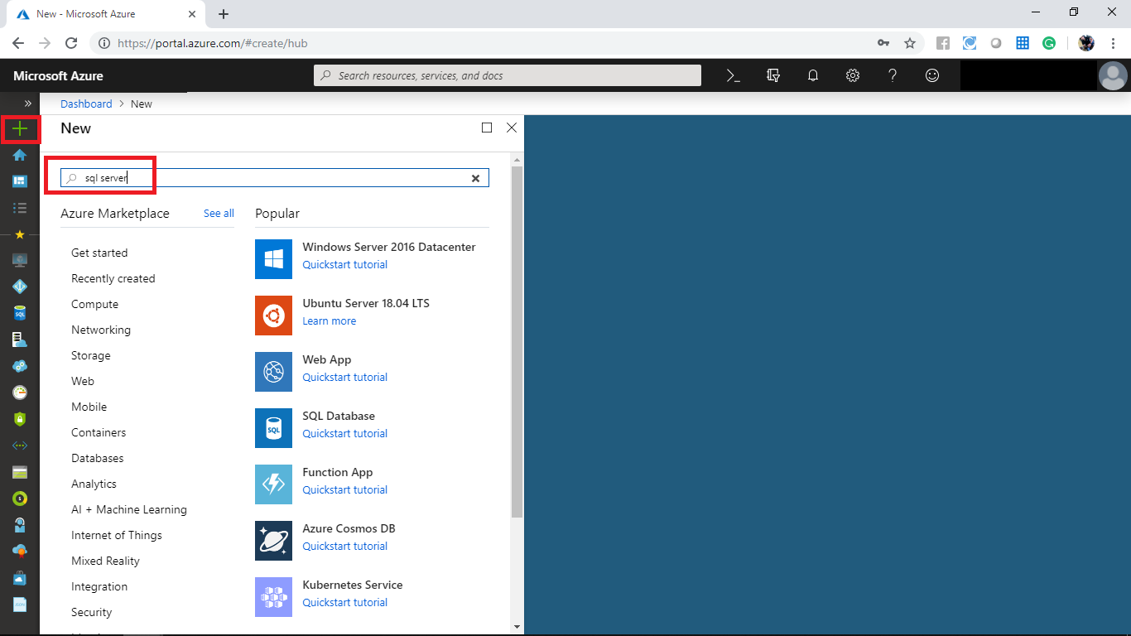

When it prompts click on **SQL Server 2016 SP1 on Windows Server 2016**.

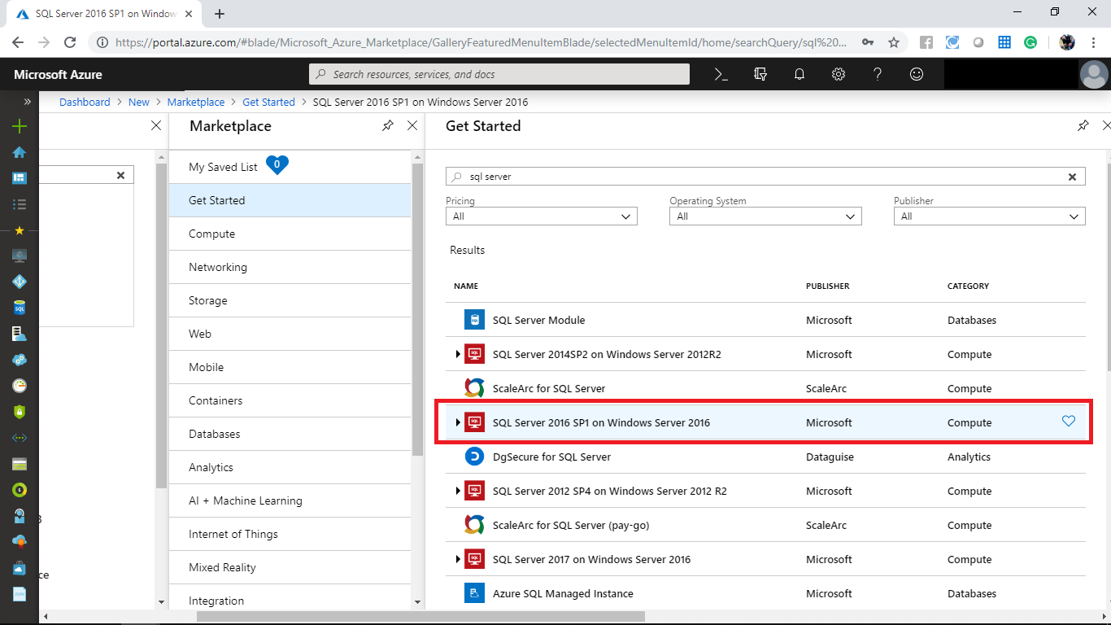

Configure the following and click on create.

* Select a software plan: Free License
* Select a deployment model: Resource Manager

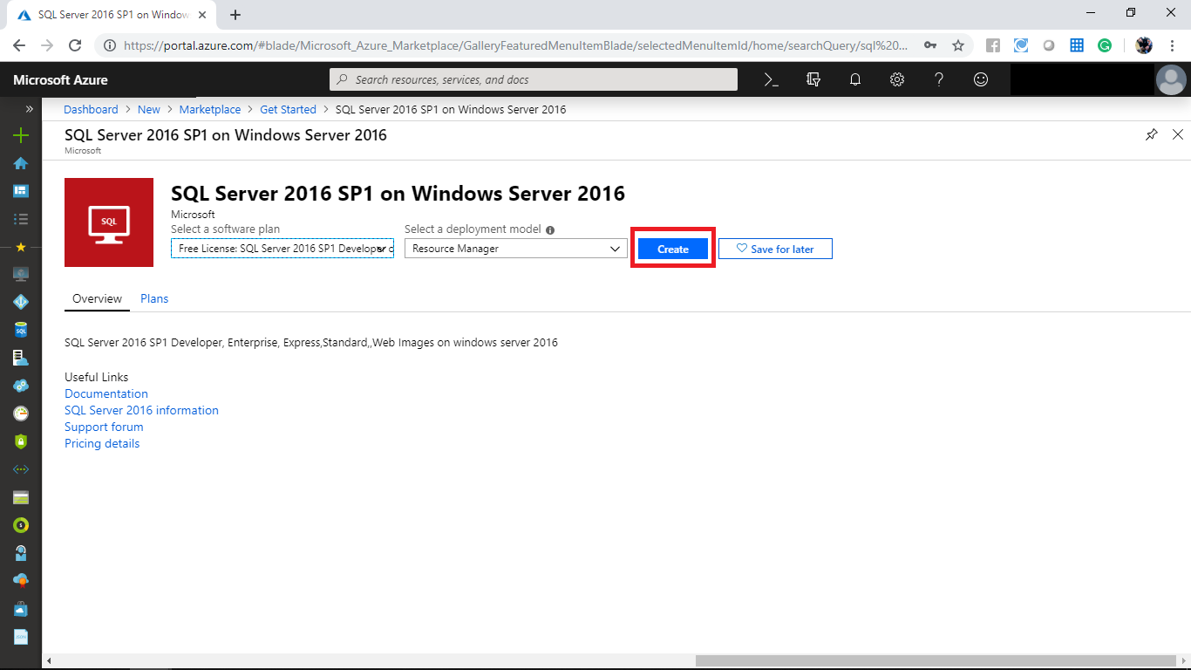

In the create Virtual Machine panel provide the following details and click on **Review+create**.

* Subscription: Select a valid resource group
* Resource group: Create a new resource group **SQLVM**
* Virtual Machine name: **fabrikamvm**
* Region: Select a valid location
* Availability option: Default
* Image: Default
* Size: Standard DS2 v2
* User name: Kishore
* Password: For your choice
* Public inbound ports: Allow selected ports
* Select inbound ports: RDP
* Already have Windows license: Yes

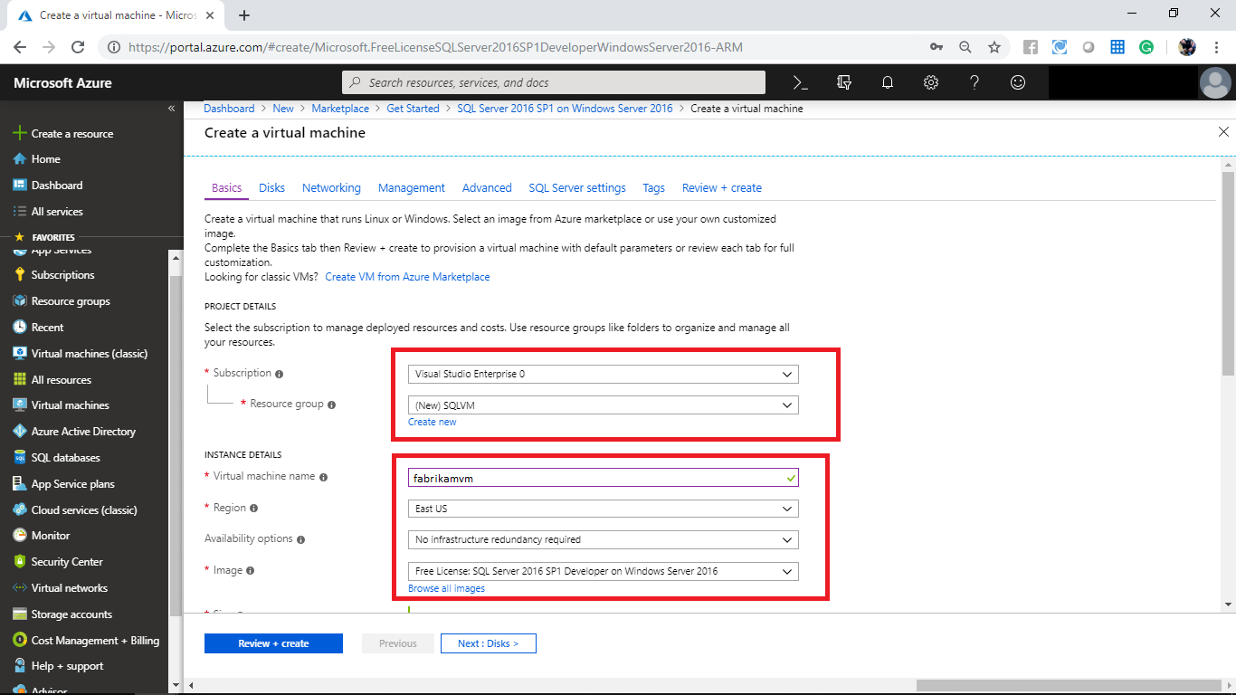

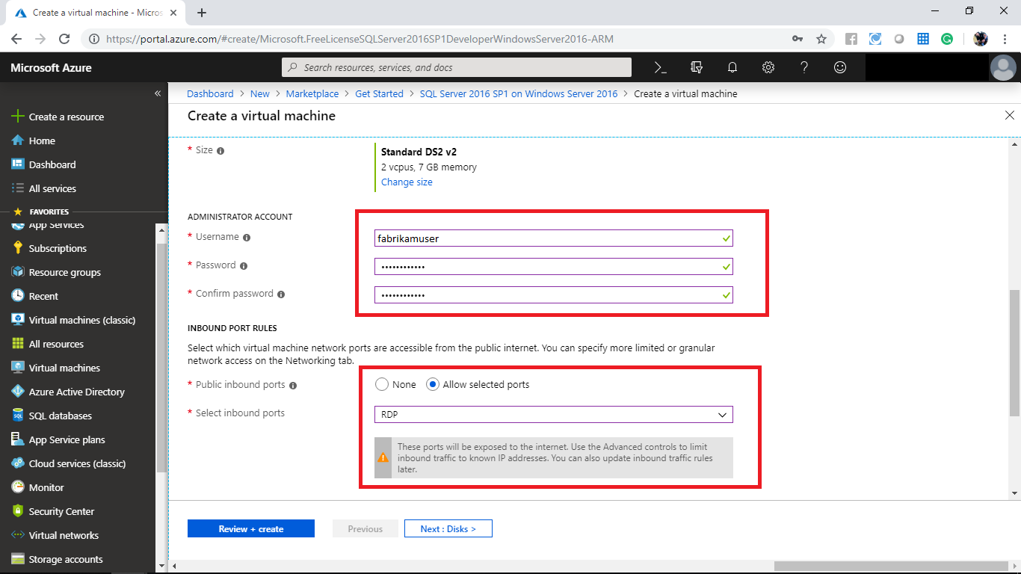

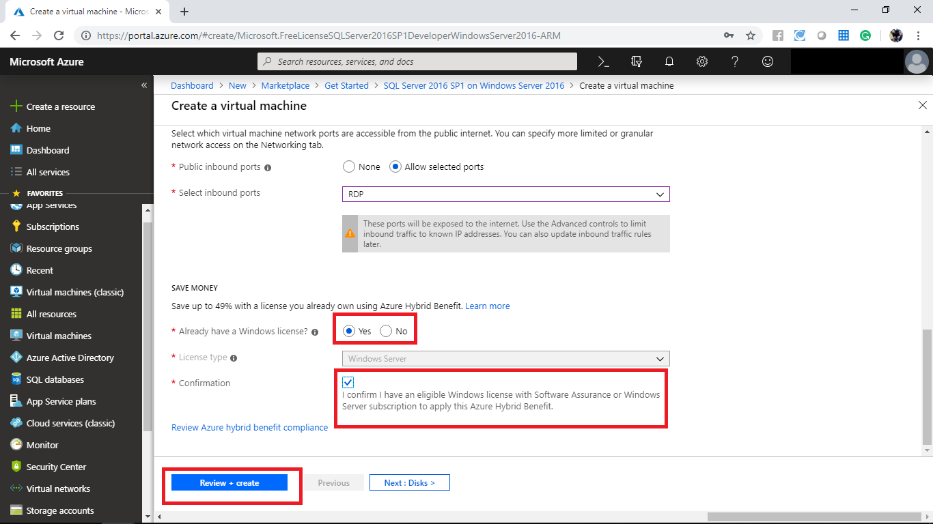

Once your validation gets paused click on create.

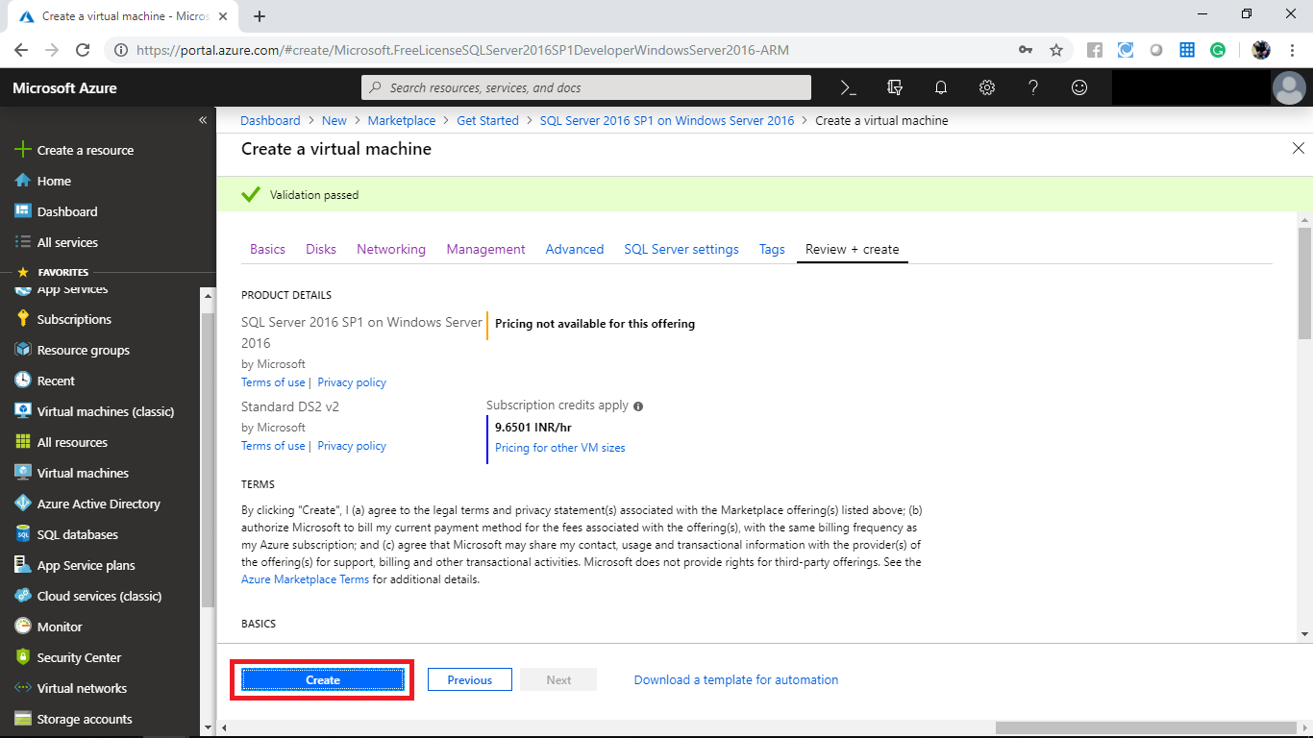

Wait until the deployment completes. Once your deployment gets completed navigated to the created resource.

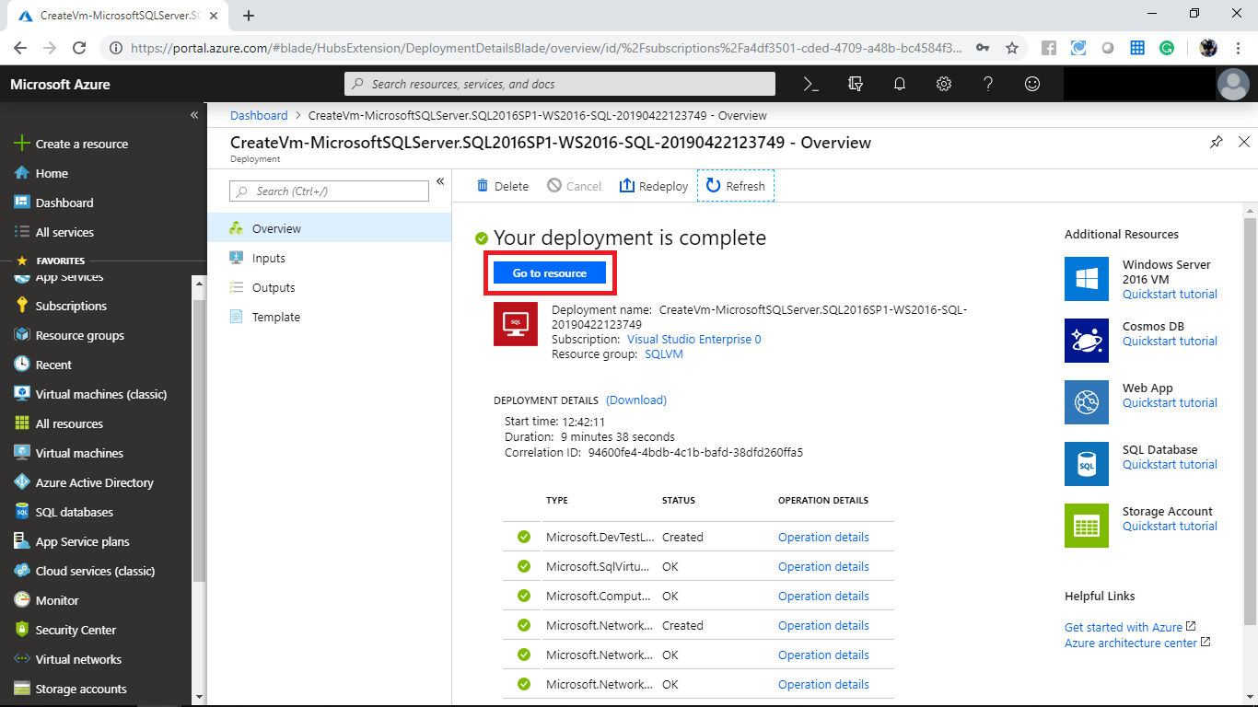

In the Virtual Machine overview panel click on connect and download the RDP file. Open the RDP file and provide the credentials which you have provided during the deployment. When it prompts click on connect.

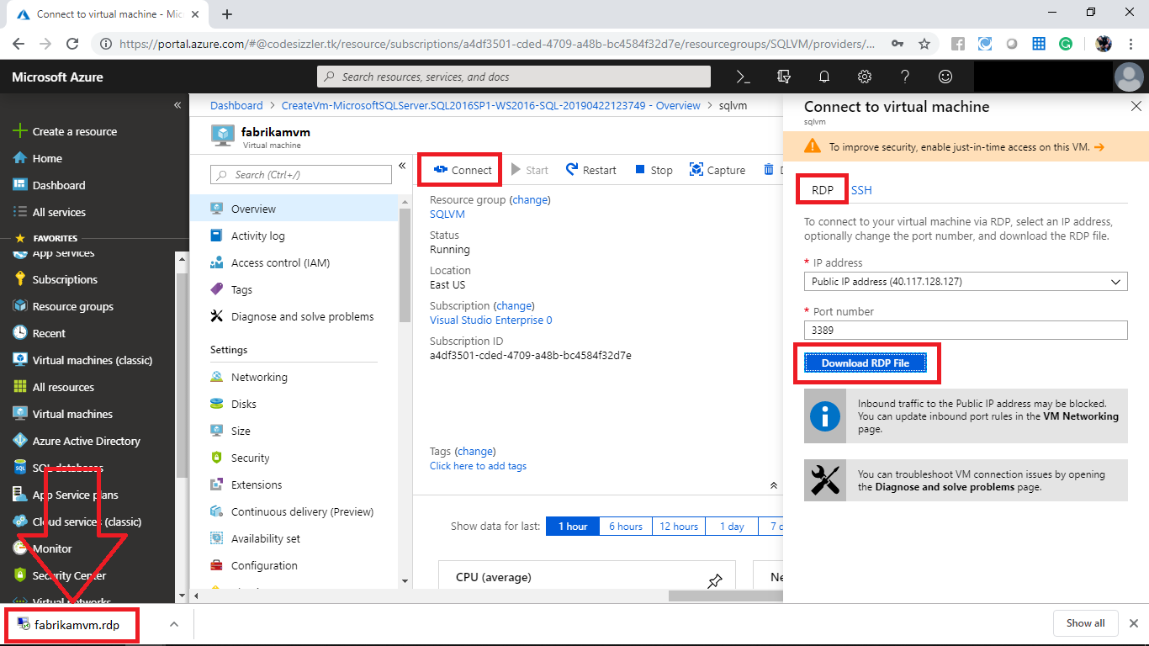

Navigate to the Virtual Machine when the network setting prompts click on **No**.

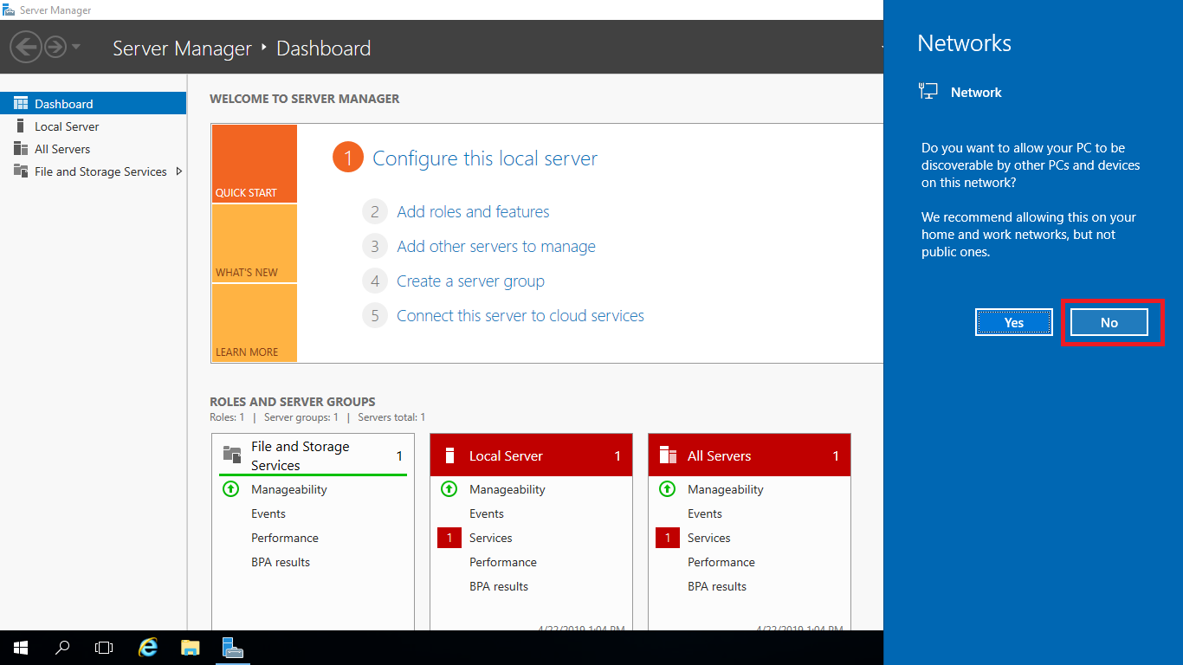

In the Virtual Machine click on start and search for **ssm**. From the result select **Microsoft SQL Server Management Studio 17.**

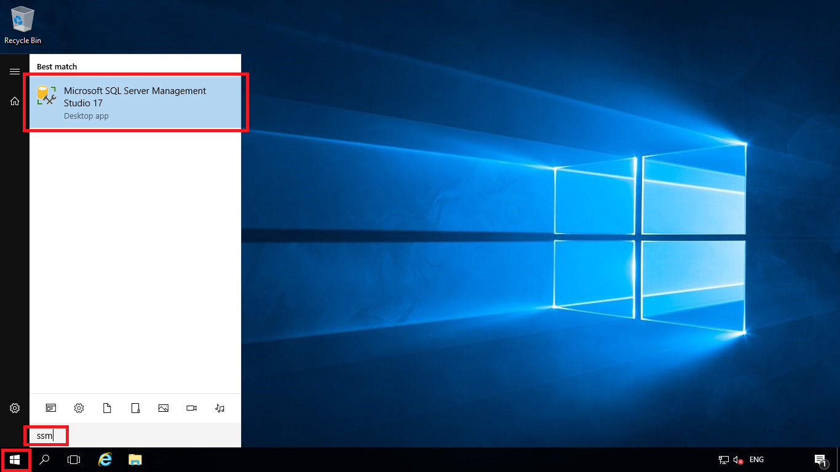

When it prompts provide the following details and click on connect.

* Server type: Database Engine
* Server name: fabrikamvm
* Authentication: Windows Authentication

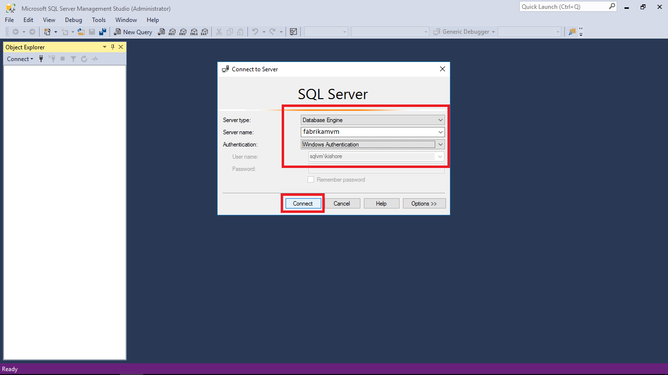

In the SQL Server panel click on new query and past the following query and execute it to create a table.

CREATE TABLE Persons (  
    PersonID int,  
    LastName varchar(255),  
    FirstName varchar(255),  
    Address varchar(255),  
    City varchar(255)   
);

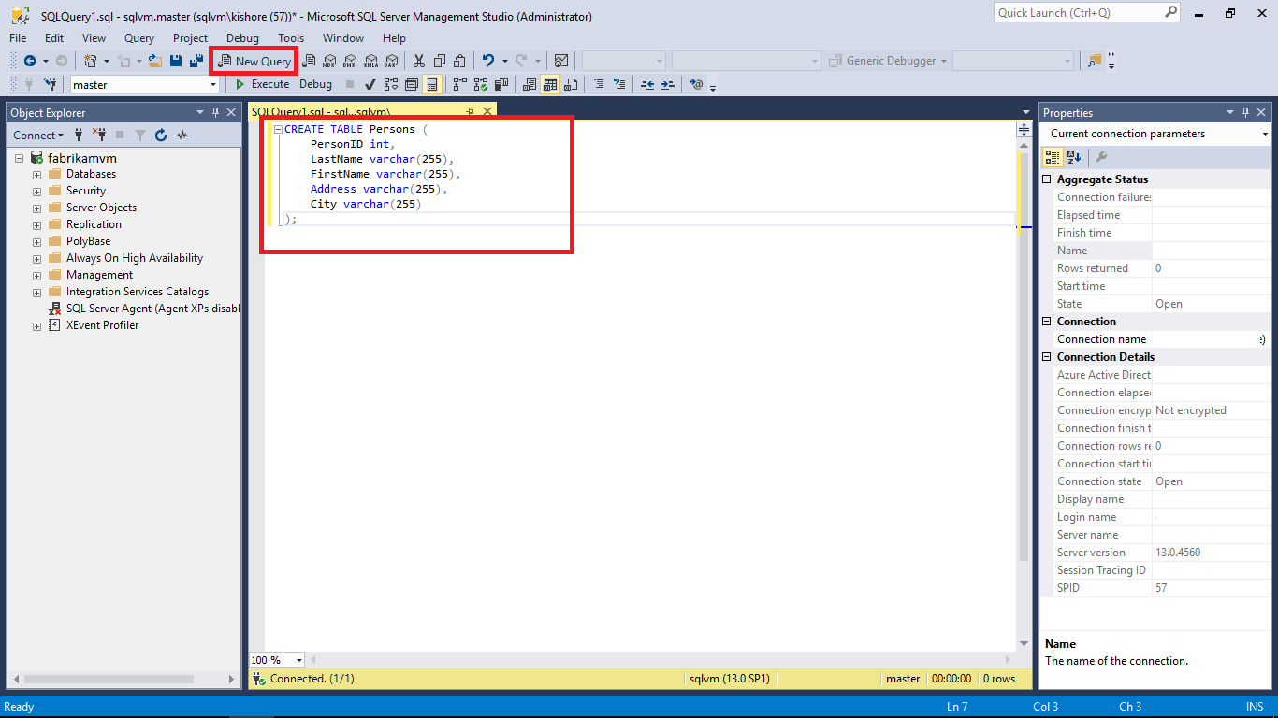

Click on **Execute** to run the query and note that the message shows **Command completed successfully**.

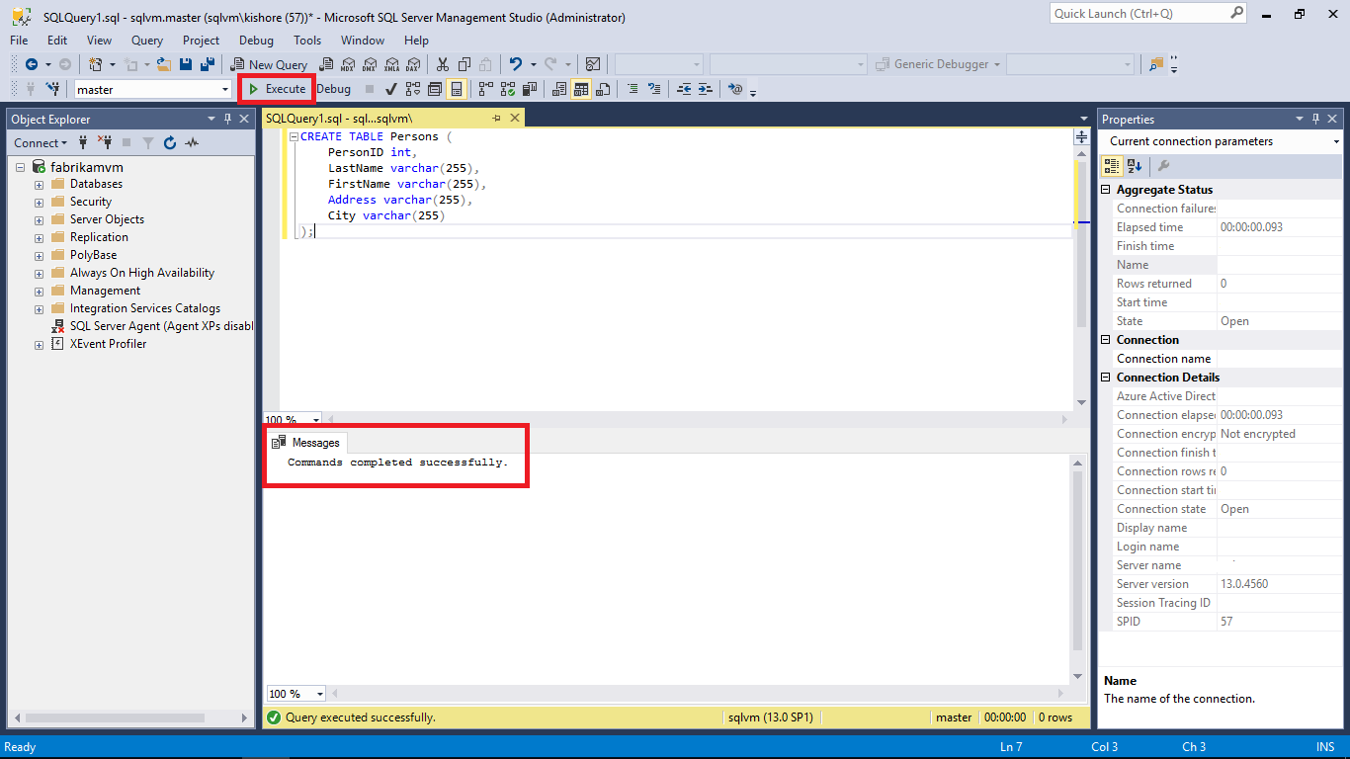

After the command run completes check that the table was created or not.

